Manuscript Submission Guidelines
Publishing Excellence With Integrity

Founded in 2016

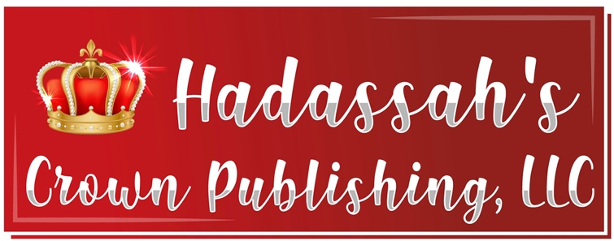
  - 
“Do not worry about anything, but pray about everything.” Phillipians 4:6
“Thus says the Lord, the God of Israel, 'Write all the words which I have spoken to you in a book…’” Jeremiah 30:2
“Let all things be done decently and in order.” 1 Corinthians 14:40

To Consider

Prepare your submission as if you are turning in a paper in English class. To receive an ‘A,’ you must be conscientious and turn in your best work. When preparing a manuscript for publication, it is important to have this same mindset.
Manuscripts should be complete before sending. Sending multiple files at various times complicates and delays the publishing process. Changes requested after the submission may result in an increased fee. Take your time and do not rush the process. Prepare your work as though it will be published as is and be a perfectionist.
Before submitting your manuscript, use Spell and Grammar Check or Grammarly, proof read it at least three times, checking for the following:
- Is the story or content shared in an interesting, engaging way? Would I want to read it?
Are just the basics of the story given, or has the language been enhanced so the reader has a pleasurable reading experience?
- Is the tense consistent throughout? (Ensure past and present tense are not switched).
- Have you run the automatic spelling and grammar check? Word has this tool. Grammarly.com is a good website for checking your work.
- Has dialogue been used and punctuated correctly? For example, “I don’t know what you were thinking,” Phyllis said to Peter.
- Each time a different person speaks, a new paragraph is needed. End punctuation is inside the closing quotation marks.
- Vary sentence and paragraph beginnings.
- Avoid overusing any word, such as so, then, always, but, and, etc.
- Check for repeated or omitted words.
- Check for consistent pronoun references. Do not, for example, switch between first (I, me, my), second (you, your) and third (he/she/them, him/her/them, his, her, their) person pronouns.
- Manuscripts should be typed in Times New Roman, 12-point font with 1.5 line spacing and justified. If headings or other fonts are used, but sure there is consistency throughout your manuscript, including font size.
- Indentions should be set to five spaces. Leave ONE space between sentences, not two.
- If a Table of Contents page is included, it should not have the page numbers listed. They will change.
- If scripture is included, be sure the reference listed matches the verse cited. Cite the version of the Bible used. Make sure the scripture is not linked to a web page it may have been copied and pasted from.
- Are names and headings consistent throughout? Is Grandpa Fred used in one chapter, but he becomes Grandpa Pete in other chapters?
- Have you asked beta readers to review your manuscript and provide feedback?
(A beta reader is usually a test reader of an unreleased work of literature or other writing, who gives feedback from the point of view of an average reader to the author. A beta reader is not a professional and can therefore provide advice and comments similar to the opinions of an average reader.)
 |  | Your Bio  Your bio should convince your reader that you are qualified to write the book you have penned. One to two paragraphs are plenty. It is not necessary to share your entire life story here.
Book Description  This should be written to help your book sell. Why should anyone want to read it? Grab their attention! But don’t give away the story line. Make them want to purchase and read it! |  | 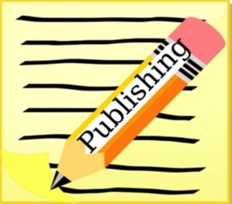

Dedication
Whose honor is the book written in?
Acknowledgements  Who helped you throughout your process? God, beta readers, illustrator, photographer, hair stylist, family, publisher.... |  | Headshot  This should be a professional photo and not a selfie. Ideally, it will not include other people who have been cropped out or backgrounds filled with stuff. It is okay to show your personality in a creative, tasteful way. A JPG or PNG file of high quality should be submitted.  Clipart/Images  If any clipart or images are included, you must have rights to use them. Please share receipts or subscriptions that confirm your rights.  Borrowed Text  Single line or short quotes are acceptable if the speaker is mentioned. Any other information borrowed from another source (book, newspaper, magazine or website) must be cited at the end of the manuscript under Works Cited or Bibliography.
Thank you for following our submission guidelines. Have questions? Call us at 864-708-1214 or email us at HadassahsCrown@gmail.com. Visit our website: HadassahsCrownPublishing.com. Follow us on Facebook, Instagram & Twitter.

